August 23, 2022

Dear Pastors, Lay Ministers, and Local Churches,

- Included here are the attachments that will open all of the forms required to complete your Church Conference reports. ***PLEASE USE THESE FORMS, CREATED JUST FOR OUR DISTRICT. Our forms are also on our North District website: www.northdistrictumc.org. Most of THE FORMS ON THE CONFERENCE WEBSITE are the same, however, please note that we have worked in our office to simplify and streamline this process and eliminate unnecessary forms and parts of forms.

- Pastor’s Report – Due in Charge Conference Packet

- You will receive in this download a SPRC Clergy Assessment piece. DUE IN CHARGE CONFERENCE PACKET.

PLEASE BE SURE TO HAVE ALL OF YOUR CHURCH CONFERENCE FORMS PROPERLY COMPLETED, SIGNED AND INTO LONNA’S OFFICE in TEXARKANA AS SOON AS POSSIBLE.

Yours in Christ,

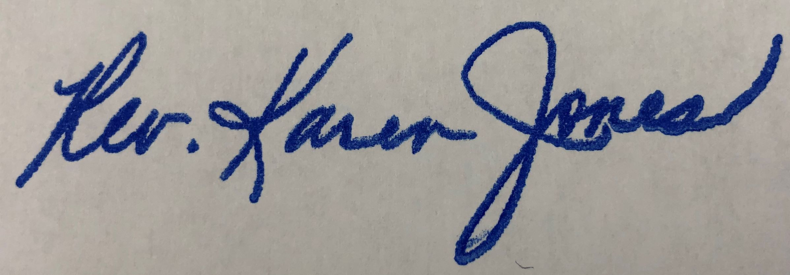
Karen

